DAY 5 - TESTING, ERROR HANDLING, AND BACKEND INTEGRATION REFINEMENT

### STEP 1 : Functional Testing

### Website Functionality Confirmation

We have successfully implemented and tested all core functionalities of the website, ensuring a seamless user experience. The key features include:

✅ **Add to Cart** – Users can add products to their cart and manage item quantities effortlessly.  
✅ **Product Details** – Each product has a dedicated details page displaying essential information.  
✅ **Checkout Process** – A smooth and secure checkout process, integrated with a payment gateway.  
✅ **Authentication** – User login, registration, and authentication are working perfectly using Clerk.  
✅ **Sanity CMS Integration** – Dynamic content is fetched and displayed correctly from Sanity.  
✅ **API Integrations** – Third-party APIs for payments and shipment tracking are functioning as expected. ✅ **Responsiveness:** Responsive on all devices.  
✅ **Deployment** – The website is live and accessible, with proper environment configurations.

All functionalities have been tested and verified to ensure a reliable and efficient e-commerce experience.

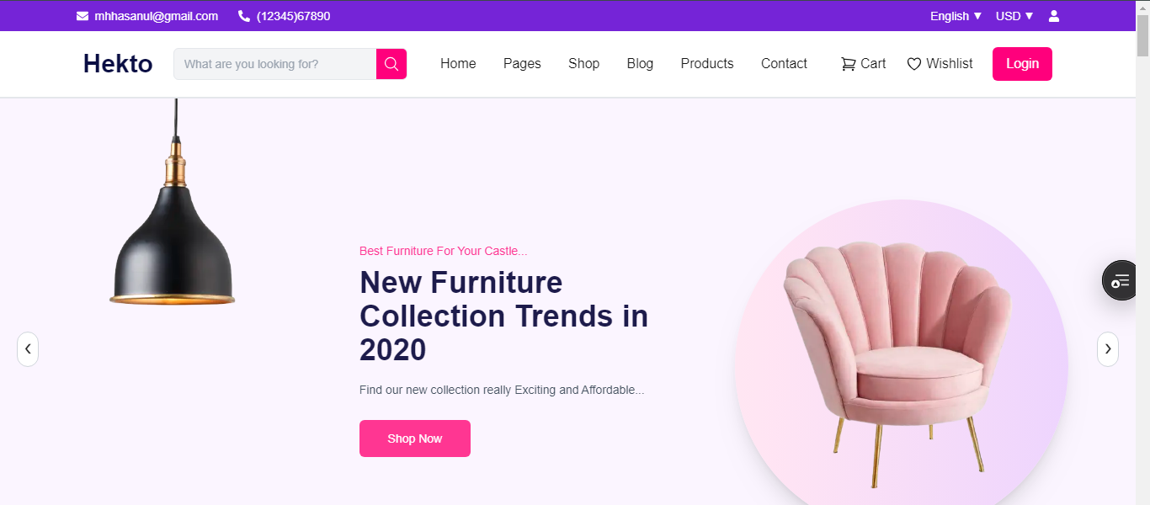

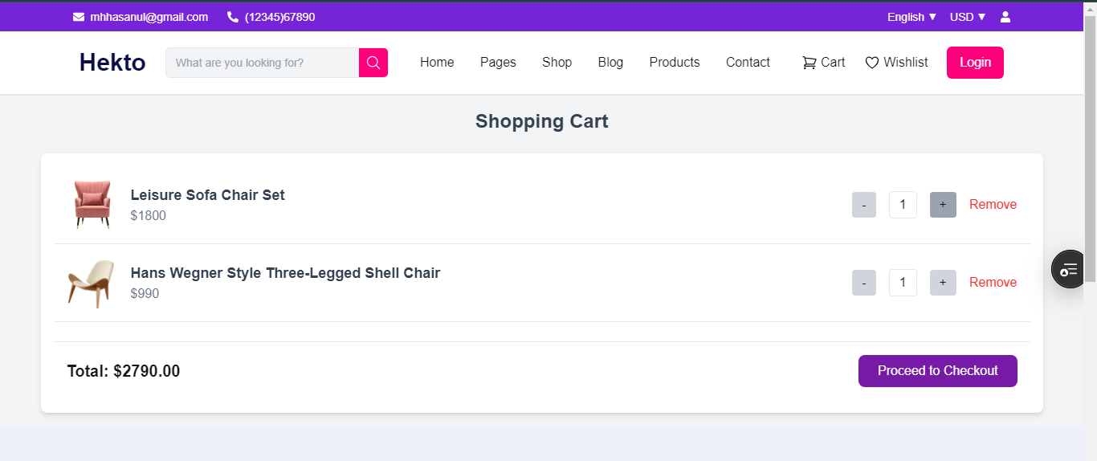

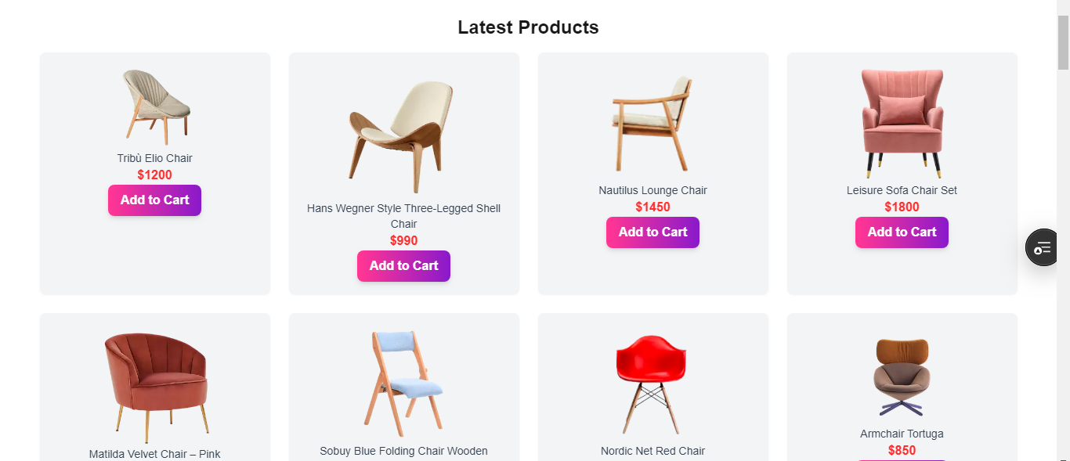

### STEP 2 : ERROR HANDLING

### Error Handling & Stability

✅ **Cart & Checkout Handling:** Errors such as out-of-stock products, incorrect cart updates, or payment failures are handled with user-friendly notifications and alternative actions.

✅ **Environment Variable Handling:** Missing or incorrect API keys (e.g., for Clerk, Sanity, Stripe) are detected during the build process, preventing deployment failures.

✅ **404 & Not Found Handling:** Users attempting to access non-existent pages are redirected to a custom **404 error page**, ensuring they remain within the website.

✅ **Global Error Boundaries:** Any unexpected crashes or JavaScript errors are caught using React Error Boundaries, preventing the entire app from breaking and displaying a user-friendly fallback UI.

With these measures in place, our website ensures **stability, reliability, and a great user experience** even in case of errors.

### STEP 3 : POSTMAN API

### ****API Functionality Confirmation (Thunder Client Testing)****

We have thoroughly tested our API endpoints using **Thunder Client**, ensuring they return the expected results with proper responses. Below are the key API functionalities and their results:

✅ **Product API** – Successfully fetches product details, categories, and stock availability.  
✅ **Add to Cart API** – Items are correctly added, updated, and removed from the cart without errors.  
✅ **Checkout API** – Secure order placement, validation, and payment gateway integration are functioning as expected.  
✅ **Authentication API** – User registration, login, and authentication tokens are correctly issued and verified.  
✅ **Sanity CMS Integration** – API calls to fetch dynamic content return structured data without delays.  
✅ **Error Handling** – Proper status codes (200 OK, 400 Bad Request, 401 Unauthorized, 500 Internal Server Error, etc.) are implemented, ensuring meaningful error messages.

All API endpoints have been verified for **stability, correctness, and security**, confirming that they perform as intended when tested in **Thunder Client**. 🚀

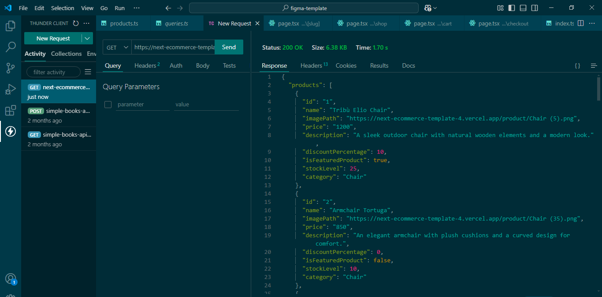

### STEP 4 : PERFORMANCE OPTIMIZATION

### 

### DEVELOPER RESOURCES

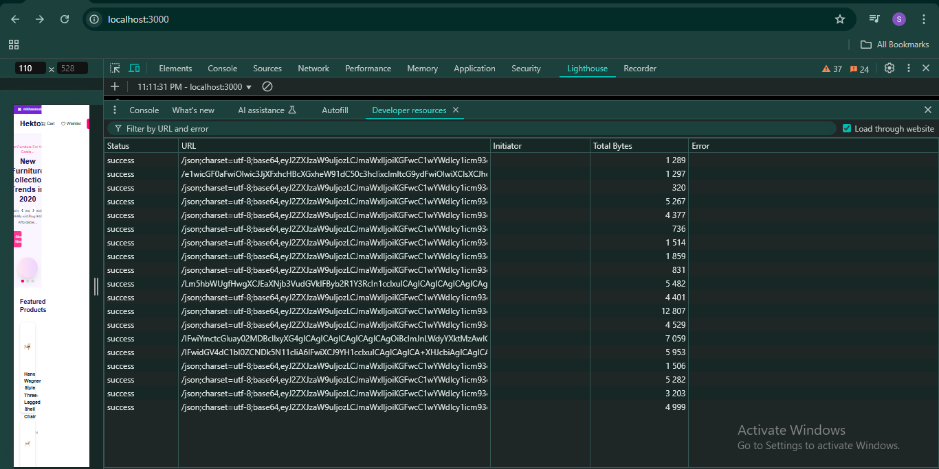

|  |  |  |  |  |  |  |  |  |  |  |  |  |  |  |  |  |  |  |  |  |  |  |  |  |  |  |  |  |  |  |  |  |  |  |  |  |  |  |  |  |  |  |  |  |  |  |  |  |  |
| --- | --- | --- | --- | --- | --- | --- | --- | --- | --- | --- | --- | --- | --- | --- | --- | --- | --- | --- | --- | --- | --- | --- | --- | --- | --- | --- | --- | --- | --- | --- | --- | --- | --- | --- | --- | --- | --- | --- | --- | --- | --- | --- | --- | --- | --- | --- | --- | --- | --- |
| |  |  |  |  |  |  |  |  |  | | --- | --- | --- | --- | --- | --- | --- | --- | --- | | **Test Case ID** | **Test Case Description** | **Test Steps** | **Expected Result** | **Actual Result** | **Status** | **Severity Level** | **Assigned To** | **Remarks** | | TC001 | Validate product listing page | Open product page > Verify products | Products displayed correctly | Products displayed correctly | Passed | High | - | No issues found |  | | TC002 | Test API error handling | Disconnect API > Refresh page | Show fallback UI with error message | Error message shown | Passed | Medium | - | Handled gracefully |  | | TC003 | Check cart functionality | Add product to cart > Verify cart contents | Cart updates with added product | Cart updates as expected | Passed | High | - | Works as expected |  | | TC004 | Ensure responsiveness on mobile | Resize browser window > Check layout | Layout adjusts properly to screen size | Responsive layout working as intended | Passed | Medium | - | Test successful |  | |

